**Project Design Phase-II**

**Technology Stack (Architecture & Stack)**

|  |  |
| --- | --- |
| Date | 03 October 2022 |
| Team ID | PNT2022TMID20316 |
| Project Name | AI- powered Nutrition Analyzer for Fitness Enthusiasts |
| Maximum Marks | 4 Marks |

**BLOCK DIAGRAM:**

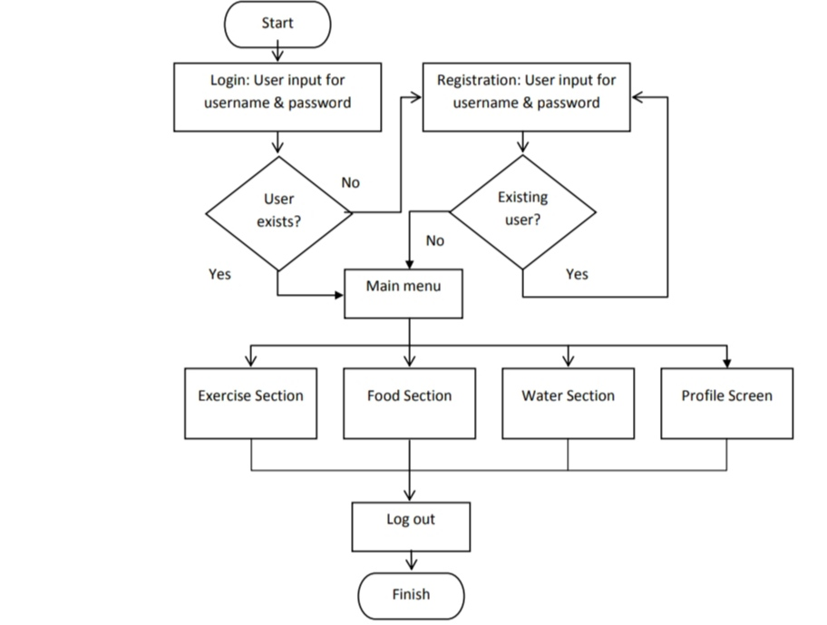

**Table-1 : Components & Technologies:**

Guidelines:

Include all the processes (As an application logic / Technology Block)

1. Provide infrastructural demarcation (Local / Cloud)
2. Indicate external interfaces (third party API’s etc.)
3. Indicate Data Storage components / services
4. Indicate interface to machine learning models (if applicable)

|  |  |  |
| --- | --- | --- |
| **S.No** | **Component** | **Description** |
|  | username | |  | | --- | | Username of the user | |
|  | Food_List | Unique identifier of the food item |
|  | Liquid | Amount of the beverage or water intake |
|  | Meal | Image URL that links to the meal image |
|  | Post_Like | Unique identifier of the user |
|  | Recipe | Name of the recipe |
|  | Recipe_Steps_Ingredients | Ingredients of the recipe |
|  | Route | Latitude on the map |
|  | nutrients | Name of the nutrients |
|  | post_content | Content of the post |
|  | reminder_id | Unique identifier of the reminder item |

**Table-2: Application Characteristics:**

| **S.No** | **Characteristics** | **Description** | **Technology** |
| --- | --- | --- | --- |
|  | Open-Source Frameworks | List the open-source frameworks used | Technology of Opensource framework |
|  | Security Implementations | List all the security / access controls implemented, use of firewalls etc. | e.g. SHA-256, Encryptions, IAM Controls, OWASP etc. |
|  | Scalable Architecture | Justify the scalability of architecture (3 – tier, Micro-services) | Technology used |
|  | Availability | Justify the availability of application (e.g. use of load balancers, distributed servers etc.) | Technology used |
|  | Performance | Design consideration for the performance of the application (number of requests per sec, use of Cache, use of CDN’s) etc. | Technology used |